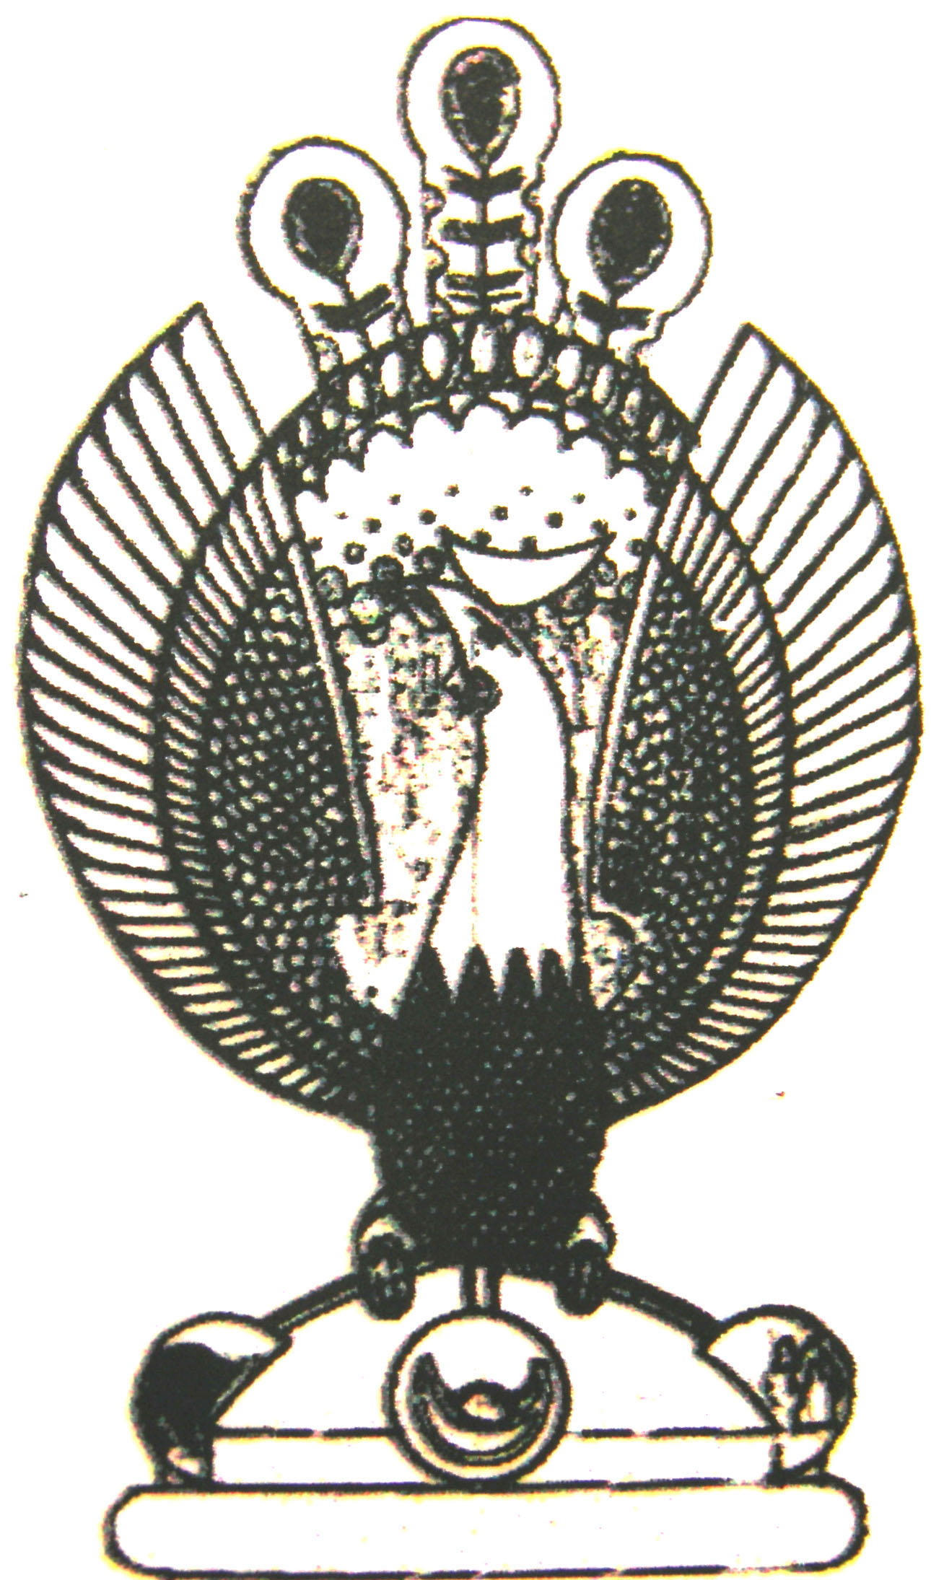

THE HERITAGE

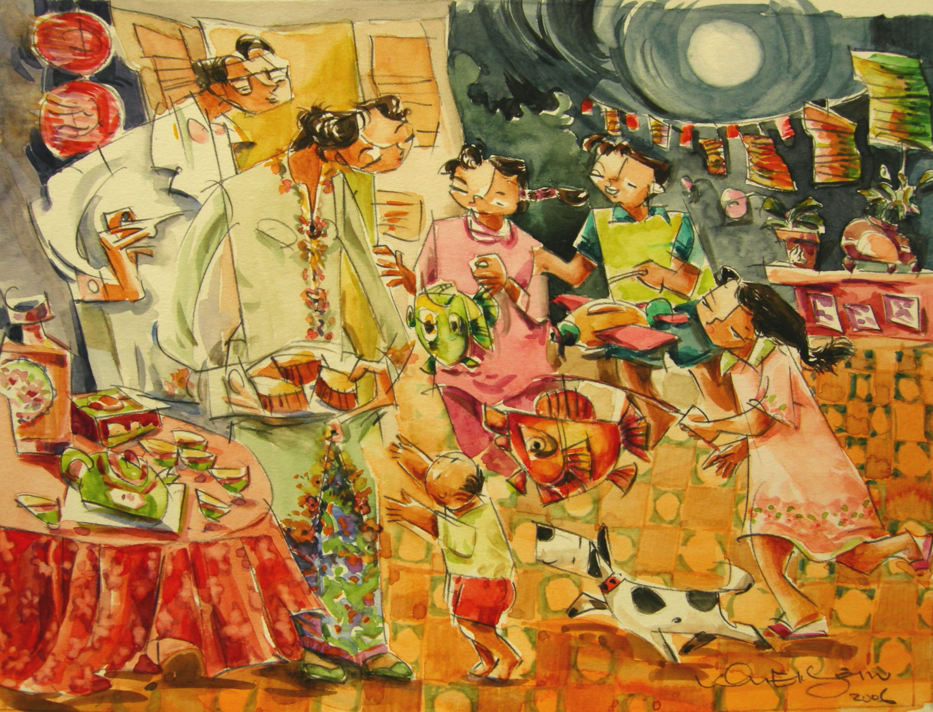

Mooncake Festival
Like the Chinese, the peranakans also celebrate the mooncake festival.

